CREATING ALB AND TARGET GROUPS

STEP1:

Sign in to the AWS Management Console: Go to https://console.aws.amazon.com/ and sign in to your AWS account.

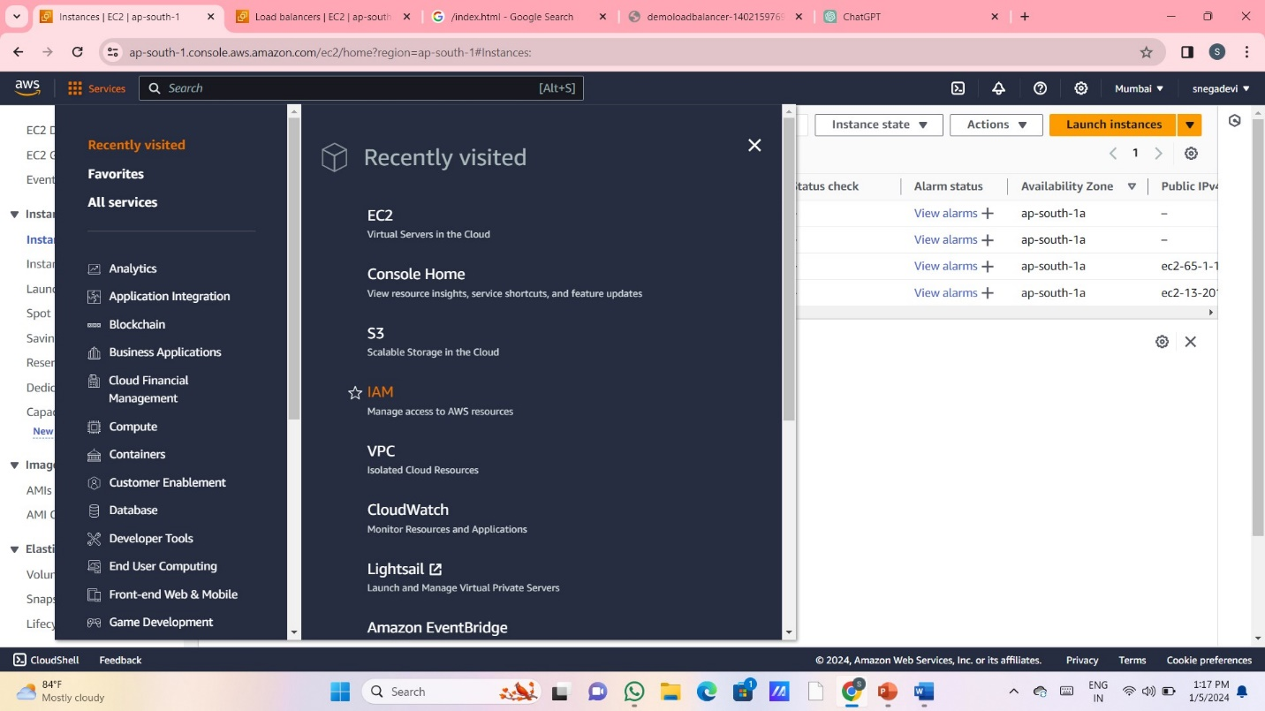

STEP2:

Navigate to the EC2 service: Click on "Services" in the top-left corner and select "EC2" from the list of services.

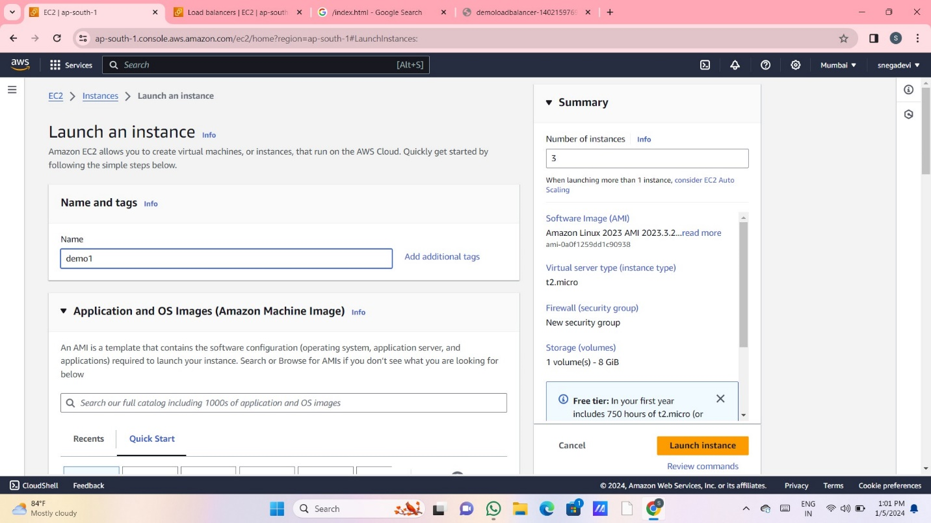

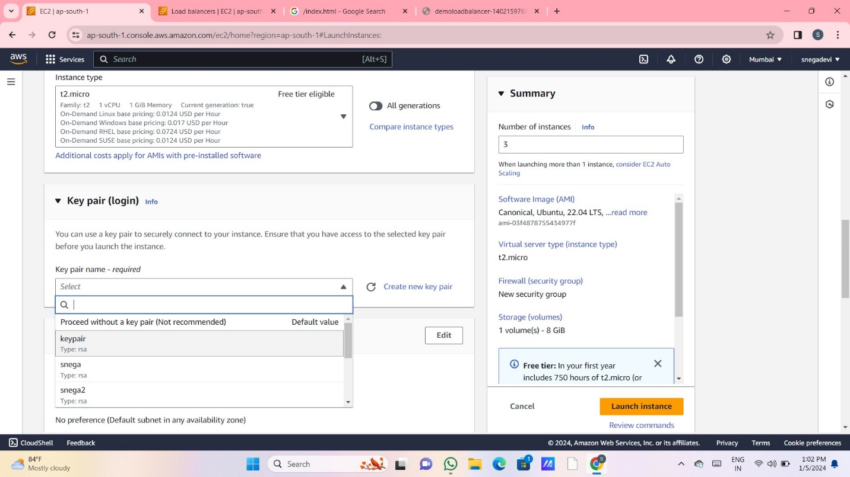

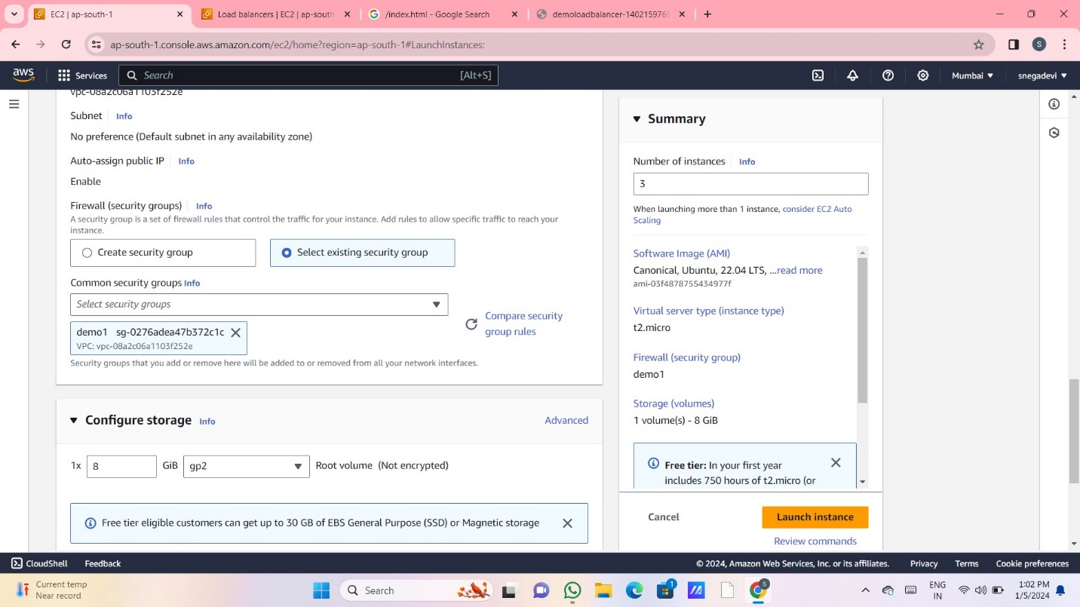

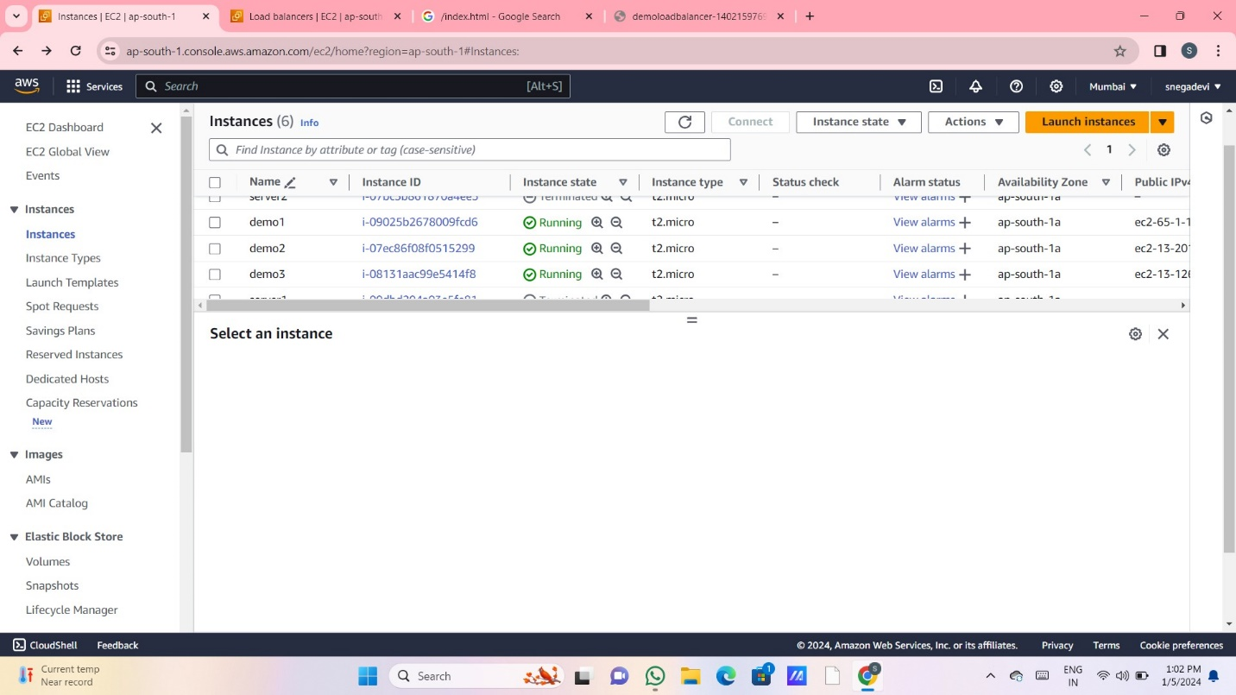

STEP3:

Create a Load Balancer:

In the EC2 Dashboard, under the "Load Balancing" section, select "Load Balancers."

Click on the "Create Load Balancer" button.

Choose a Load Balancer Type:

Select "Application Load Balancer."

Click on "Create."

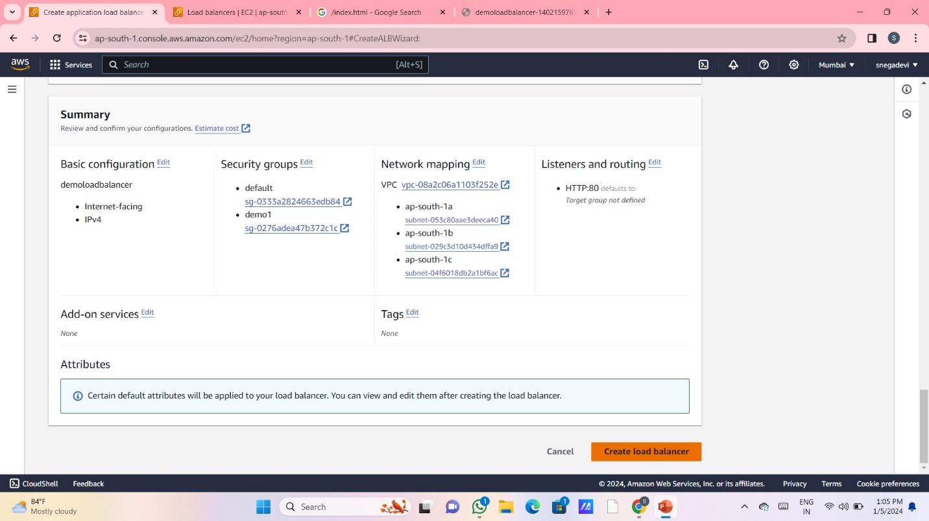

STEP4:

Configure Basic Settings:

Provide a name for your load balancer.

Choose the appropriate scheme (internet-facing or internal).

Select the VPC (Virtual Private Cloud) for your ALB.

Configure listeners (the protocol and port for client connections).

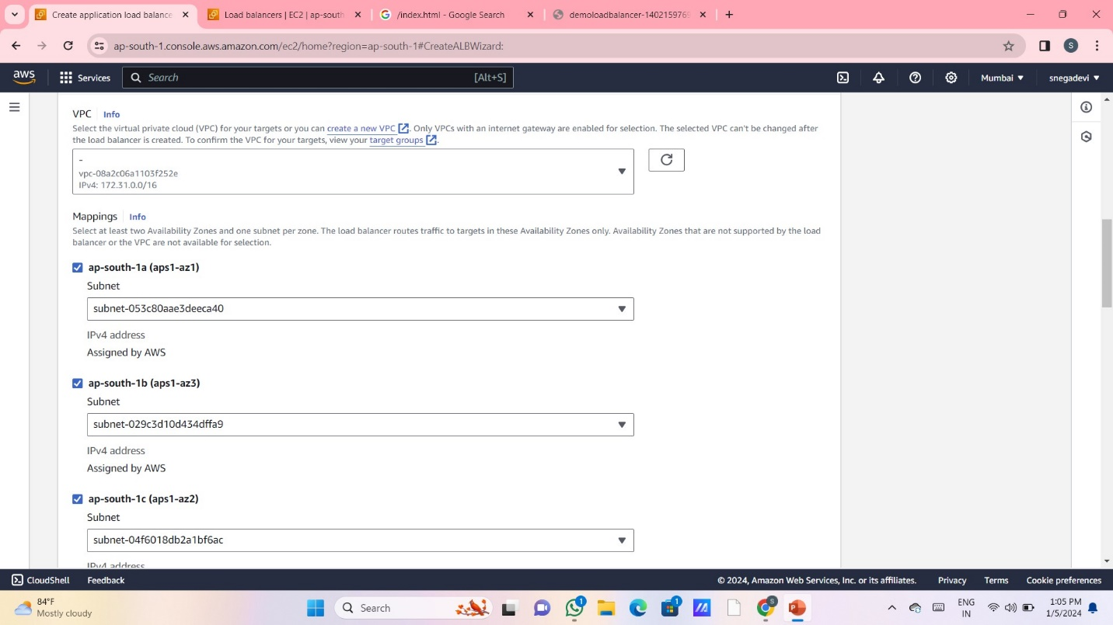

STEP5:

Configure Security Settings:

Set up security settings, such as selecting or creating a security group to control inbound and outbound traffic.

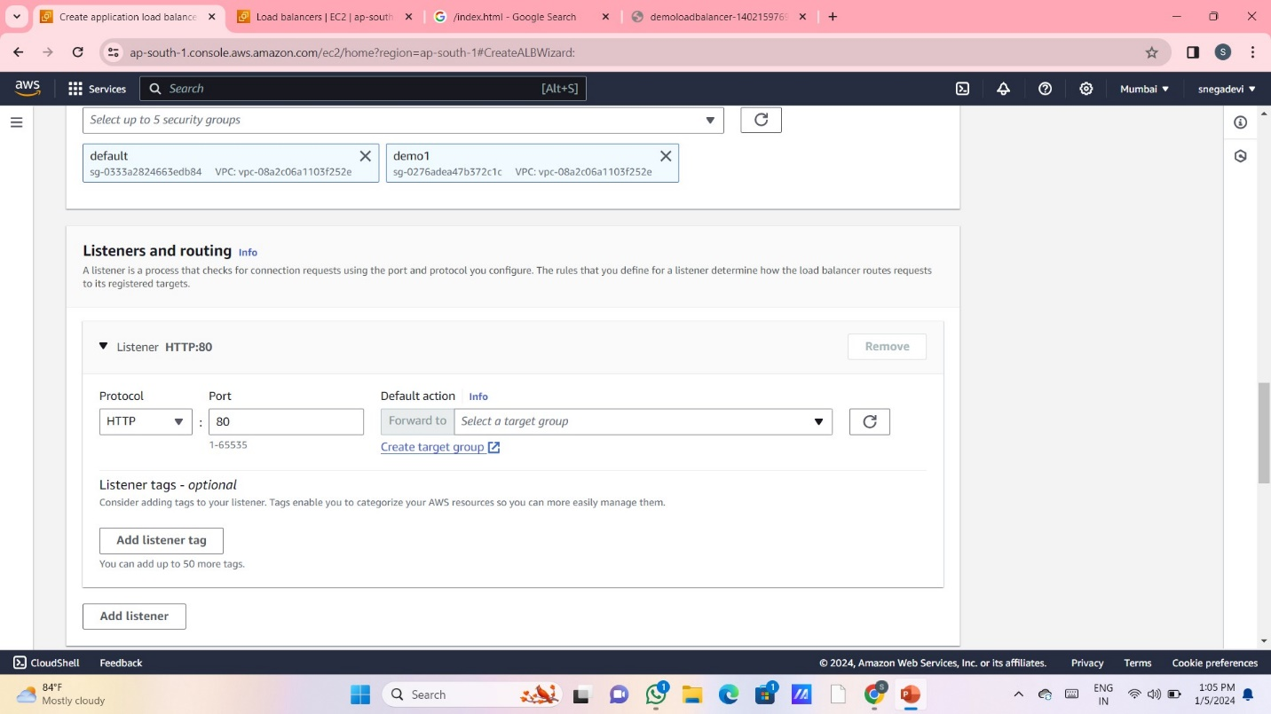

STEP6:

Configure Routing:

Configure target groups, which route traffic to registered targets (instances, containers, IP addresses, or Lambda functions).

Define the target group's name, protocol, port, target type, health check, etc.

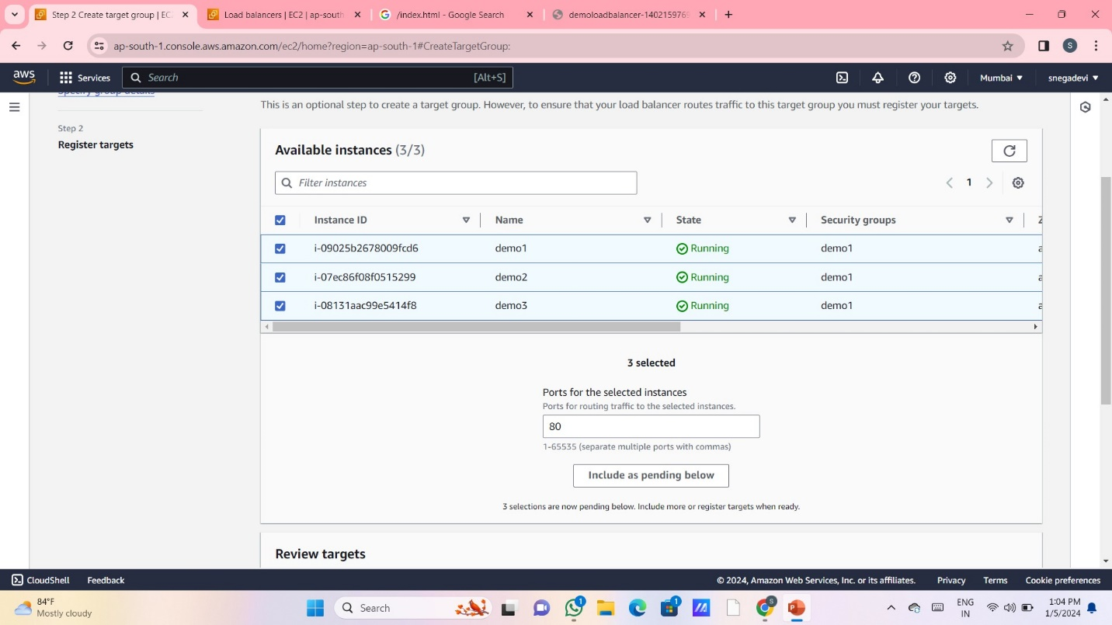

STEP7:

Register Targets:

Specify the instances or resources that will receive traffic from the ALB. These are the targets you've set up in the target groups.

Choose "Next" to proceed.

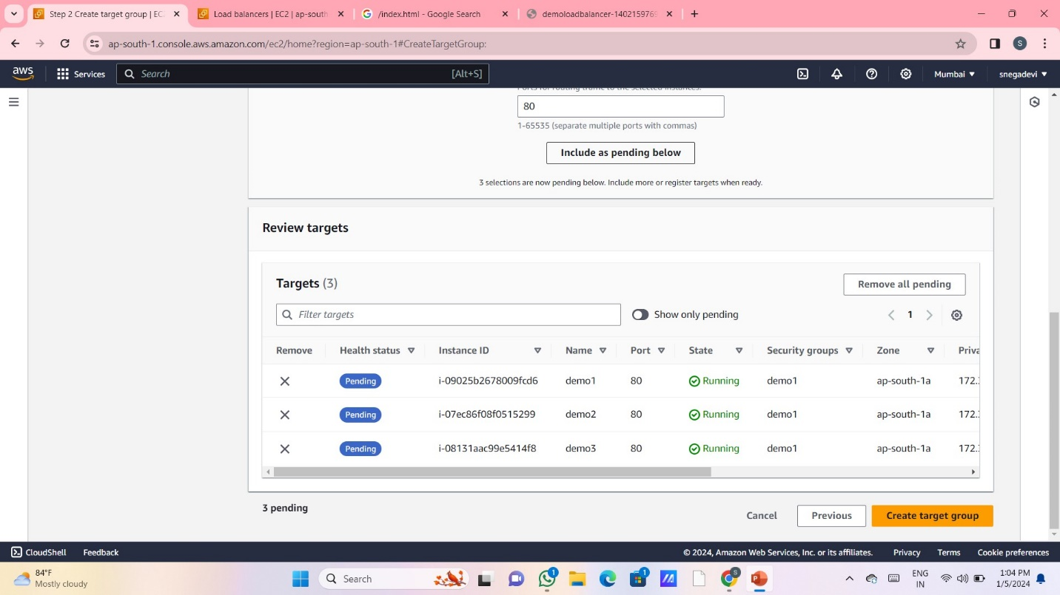

STEP8:

Review and Create:

Review the configurations you've set up for your ALB.

Click on "Create" to create the ALB.

Wait for the ALB to Provision:

Once created, it might take a few minutes for the ALB to be provisioned and become available.

Update Route Tables (if necessary):

If the ALB is internal-facing, update your route tables to route traffic to the ALB's DNS name or IP address.

Configure DNS (if necessary):

Update your DNS records if your ALB is internet-facing, pointing to the ALB's DNS name or IP address.

Test the ALB:

Access your application using the DNS name or IP address of the ALB to ensure that traffic is properly routed.

Remember to consider additional configurations such as SSL/TLS termination, logging, monitoring, and scaling policies based on your application's needs. AWS ALB offers various functionalities, and you might need to adjust settings according to your specific use case for optimal performance and security.

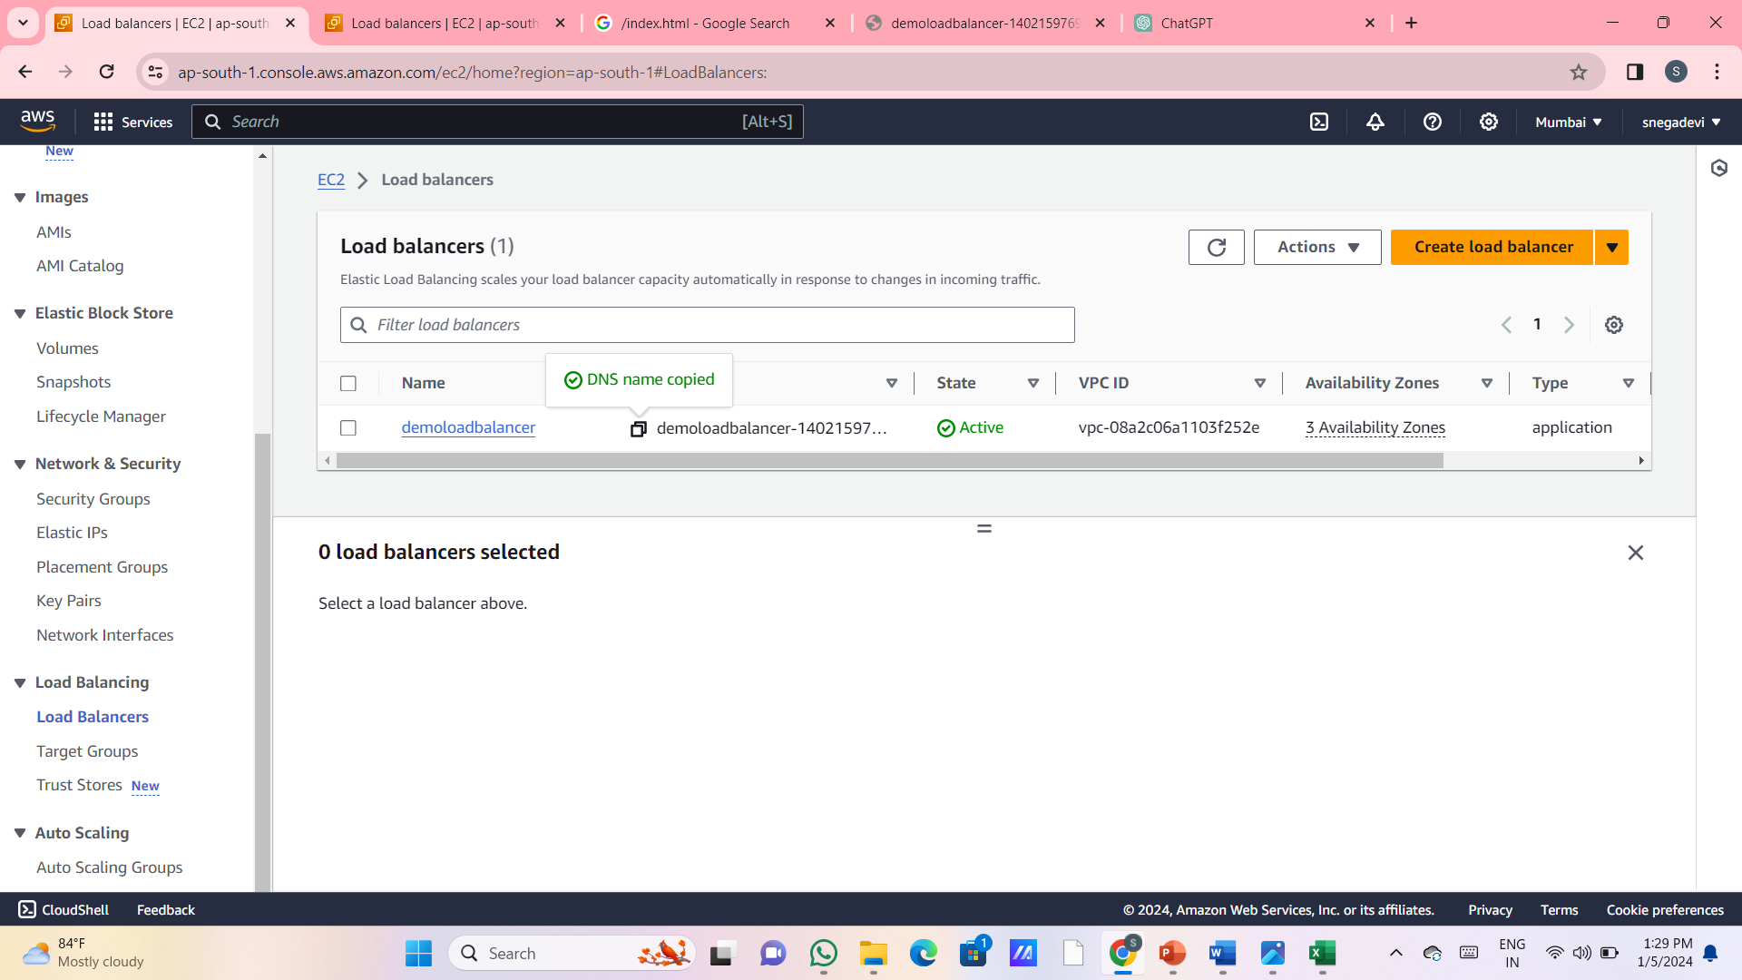Top of Form